Ex 9

First create f1 with some contents (cat>f1)

Hi hello ashok

How r u

Good morning

**Ex 9a**

#include <stdio.h>

#include<unistd.h>

int main()

{

printf("Transfer to execlp function \n");

execlp(“head”, “head”,”-2”,”f1”,NULL);

printf("This line will not execute \n”);

return 0;

}

Ex 9 b

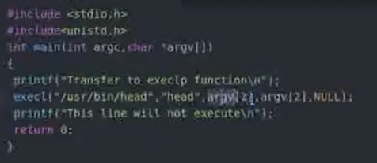

./a.out -2 f1

Ex 9c

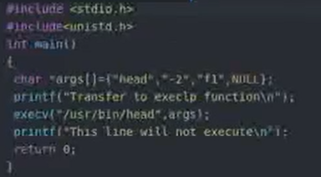

Ex 9 d

